PARALLEL TELEPHONE LINES WITH SECURITY SYSTEM

ABSTRACT
The project is designed to maintain secrecy among four parallel telephones connected to a single telephone line. When more than one phone is connected to a single telephone line, anyone can lift a phone to hear the conversation on the other one. The proposed system provides a solution for the secrecy among the telephones connected. In order to meet this requirement we are using 4 telephones connected in parallel through a single telephone line with each telephone connected through a relay in the system.
When any one of the telephone is lifted all other phones are disconnected by the relays through an arrangement of opto-couplers, the output of which is fed to a programmable microcontroller of PIC family. The microcontroller sends a signal to a 7 Segment display to display which telephone is lifted, while other telephones are disconnected by the respective relays with help of a Relay Driver IC interfaced to the microcontroller. This Project can be used in houses and offices where more than one telephone is connected in parallel through a single telephone line. The project is suitable for both incoming and outgoing calls.
Further the project can be enhanced by adding more number of phones with an intercom facility. An incoming caller id facility can also be added to it.

Note: The project needs 4 telephone instruments to be connected to the board for the functioning of the project.

BLOCK DIAGRAM
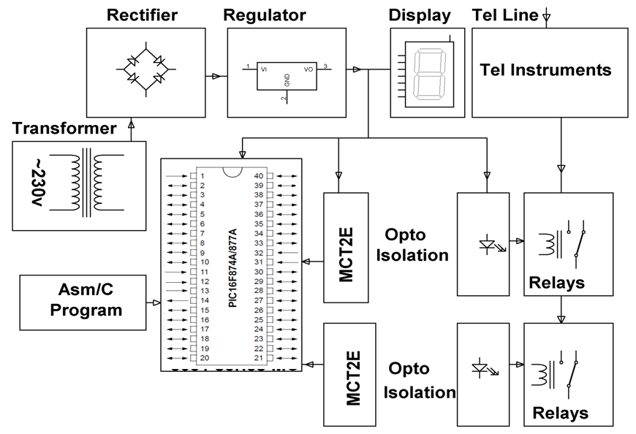

HARDWARE REQUIREMENTS:
PIC series Microcontroller, Relay Driver IC, Relays, 7 segment display, Opto-isolators, Crystal, LED, Resistors, Capacitors, Diodes, Transformer, Voltage Regulator.

SOFTWARE REQUIREMENTS:
HI TECH PICC Tool suite
Languages: Embedded C or Assembly

